Program 9
Design a java program to implement stack and queue concept.

Code:
class Stack
{
int stck[];
int tos;

Stack(int size)
{
stck = new int[size];
tos = -1;
}

void push(int item)
{
if(tos==stck.length-1)
System.out.println("Stack is full.");
else
stck[++tos] = item;
}

int pop()
{
if(tos < 0)
{
System.out.println("Stack underflow.");
return 0;
}
else
return stck[tos--];
}
}

class Queue
{
int que[];
int front, rear;

Queue(int size)
{
que = new int[size];
front = 0;
rear = -1;
}

void enqueue(int item)
{
if(rear == que.length-1)
System.out.println("Queue is full.");
else
que[++rear] = item;
}

int dequeue()
{
if(front > rear)
{
System.out.println("Queue underflow.");
return 0;
}
else
return que[front++];
}
}

public class Main
{
public static void main(String args[])
{
Stack mystack1 = new Stack(5);
Stack mystack2 = new Stack(8);

for(int i=0; i<5; i++)
mystack1.push(i);

for(int i=0; i<8; i++)
mystack2.push(i);

System.out.println("Stack in mystack1:");
for(int i=0; i<5; i++)
System.out.println(mystack1.pop());

System.out.println("Stack in mystack2:");
for(int i=0; i<8; i++)
System.out.println(mystack2.pop());

Queue myqueue1 = new Queue(5);
Queue myqueue2 = new Queue(8);

for(int i=0; i<5; i++)
myqueue1.enqueue(i);

for(int i=0; i<8; i++)
myqueue2.enqueue(i);

System.out.println("Queue in myqueue1:");
for(int i=0; i<5; i++)
System.out.println(myqueue1.dequeue());

System.out.println("Queue in myqueue2:");
for(int i=0; i<8; i++)
System.out.println(myqueue2.dequeue());
}
}
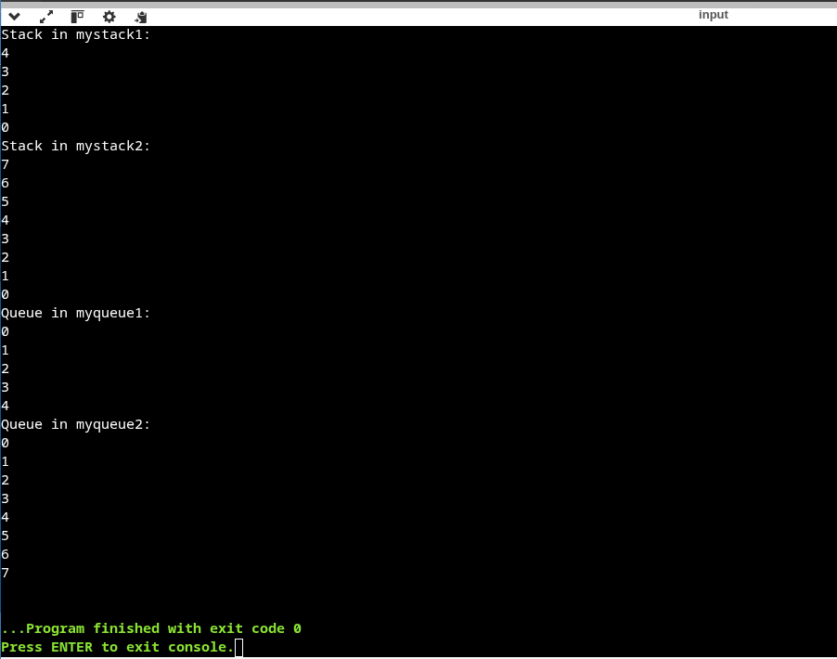
Program 10
Design a java program to create an abstract class named Shape, that contains an empty method called numberOfSides(). Provide four classes named Trapezoid, Triangle, Rectangle and Hexagon such that each one of the classes contains only the method numberOfSides(), that contains number of sides in each geometrical figure

code:
abstract class Shape
{
abstract void numberOfSides();
}

class Trapezoid extends Shape
{
void numberOfSides()
{
System.out.println("Trapezoid has 4 sides");
}
}

class Triangle extends Shape
{
void numberOfSides()
{
System.out.println("Triangle has 3 sides");
}
}

class Rectangle extends Shape
{
void numberOfSides()
{
System.out.println("Rectangle has 4 sides");
}
}

class Hexagon extends Shape
{
void numberOfSides()
{
System.out.println("Hexagon has 6 sides");
}
}

public class Main
{
public static void main(String[] args)
{
Shape s1 = new Trapezoid();
Shape s2 = new Triangle();
Shape s3 = new Rectangle();
Shape s4 = new Hexagon();

s1.numberOfSides();
s2.numberOfSides();
s3.numberOfSides();
s4.numberOfSides();
}
}
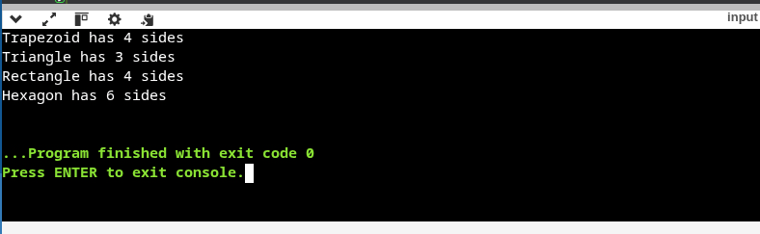
Program 11
Design a java program to show dynamic polymorphism

Code:
class MyArea
{
void area()
{
System.out.println("A concrete function called Area()");
}
}
class SQArea extends MyArea
{
double s;
void area() {
double areasq;
s=10.0;
areasq=s*s;
System.out.println("Area of Square " + areasq);
}
}
class RECTArea extends MyArea
{
double l,b;
void area() {
double arearect;
l=10.0;
b=2.0;
arearect=l*b;
System.out.println("Area of Rectangle " + arearect);
}}
public class Main
{
public static void main(String a[])
{
MyArea ma;
ma=new SQArea();
ma.area();
ma=new RECTArea();
ma.area();
}}
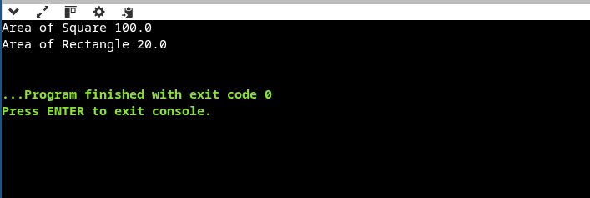
Program 12
Design a java program to implement interfaces
Code:
interface IntStack
{
void push(int item);
int pop();
}
class DynStack implements IntStack
{ private int stck[];
private int tos;
DynStack(int size)
{
stck = new int[size];
tos = -1;
}
public void push(int item)
{
if(tos==stck.length-1)
{
int temp[] = new int[stck.length * 2];
for(int i=0; i<stck.length; i++)
temp[i] = stck[i];
stck = temp;
stck[++tos] = item;
}
else
stck[++tos] = item;
}
public int pop()
{
if(tos < 0)
{
System.out.println("Stack underflow.");
return 0;
}
else
return stck[tos--];
}
}
public class Main
{
public static void main(String args[])
{
DynStack mystack1 = new DynStack(5);
DynStack mystack2 = new DynStack(8);
for(int i=0; i<7; i++)
mystack1.push(i);
for(int i=0; i<10; i++)
mystack2.push(i);
System.out.println("Stack in mystack1:");
for(int i=0; i<7; i++)
System.out.println(mystack1.pop());
System.out.println("Stack in mystack2:");
for(int i=0; i<10; i++)
System.out.println(mystack2.pop());
}
}
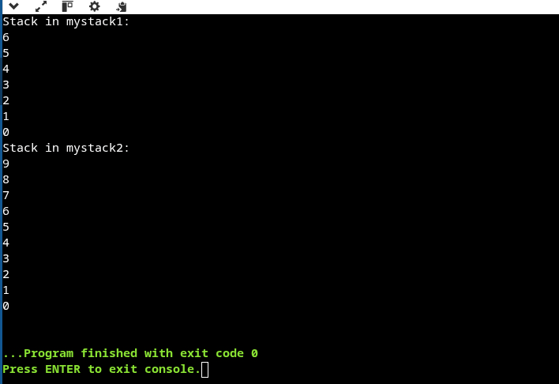
Program 13
Design a java program to create a customized exception and also make use of all 5 exception keywords.

Code:
class NSalException extends Exception
{
public NSalException(String s)
{
super(s);
}
}
class PSalException extends RuntimeException
{
public PSalException(String s)
{
super(s); //CALLING CONSTRUCTOR RuntimeException()
}
}
class Employee
{
public void decideSal(String s1) throws NSalException, PSalException,
NumberFormatException
{
int sal=Integer.parseInt(s1);
if(sal<=0)
{
NSalException no=new NSalException("Invalid Salary");
throw(no);
}
else
{
PSalException po=new PSalException("Valid Salary");
throw(po);
}
}
}
public class Main
{
public static void main(String args[])
{
try
{
if(args.length == 0)
{
System.out.println("Please provide salary as command line argument.");
return;
}

Employee e = new Employee();
e.decideSal(args[0]);
}
catch (NumberFormatException nfe)
{
System.err.println("Please enter integer values.");
}
catch (NSalException no)
{
System.err.println("Negative Salary.");
}
catch (PSalException po)
{
System.err.println("Valid Positive Salary.");
}
finally
{
System.out.println("Finally Block executing");
}
}
}
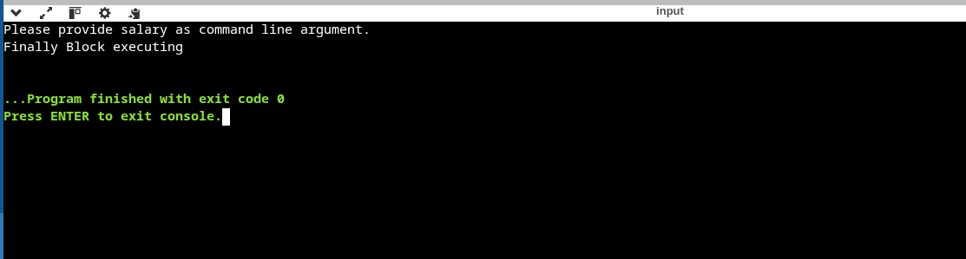
Program 14
Design a java program to sort list of names in ascending order

Code:
import java.util.*;
class SortNames
{
String name[]=new String[5];
int i,n=5;
SortNames()
{
for(i=0; i<n; i++)
{
name[i]=null;
}
}
void inputNames()
{
name[0]="Yogesh";
name[1]="Deepak";
name[2]="Aman";
name[3]="Srishti";
name[4]="Baljinder";
}
void bubbleSort()
{
int j;
String temp;
for(i=0; i<n; i++)
{ for(j=0; j<n-1-i; j++)
{ if(name[j].compareTo(name[j+1])>0)
{ temp=name[j];
name[j]=name[j+1];
name[j+1]=temp;
}
}
}
}
void displayNames()
{
for(i=0; i<n; i++)
{
System.out.println(name[i]);
}
}
}
public class Main
{
public static void main(String a[])
{
SortNames sn=new SortNames();
sn.inputNames();
sn.bubbleSort();
sn.displayNames();
}
}
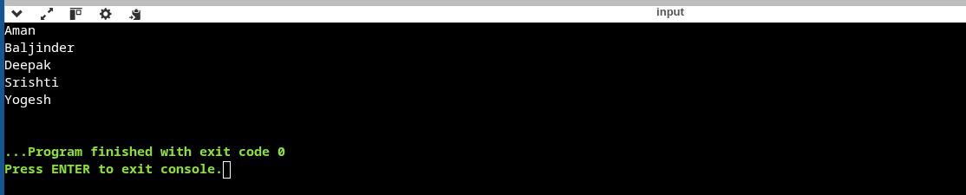
Program 15
Design a java program to create two threads: one for odd numbers and other for even numbers.

Code:
class EvenThread extends Thread
{
int num;
void set()
{
this.num=0;
}
public void run()
{
for(int i=1; i<=10; i++)
{
try
{
even();
Thread.sleep(500);
}
catch(InterruptedException e)
{
System.out.println("INTERRUPTED EXCEPTION ");
}
}
}
void even()
{
num=num+2;
System.out.println("Even : "+num);
}
}
class OddThread implements Runnable
{
int num;
void set()
{
this.num=1;
}
public void run()
{
for(int i=1; i<=10; i++)
{
try
{
odd();
Thread.sleep(500);
}
catch(InterruptedException e)
{
System.out.println("INTERRUPTED EXCEPTION ");
}
}
}
void odd()
{
num=num+2;
System.out.println("Odd : "+num);
}
}
public class Main
{
public static void main(String a[])
{
int i;
EvenThread et=new EvenThread();
OddThread ot=new OddThread();
Thread t=new Thread(ot);
et.set();
ot.set();
et.start();
t.start();
}
}
